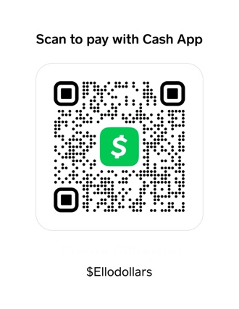
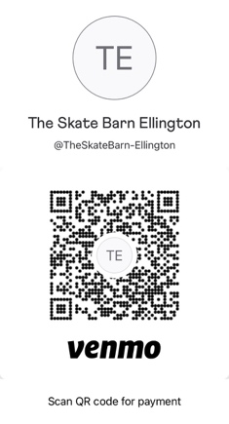

THE SKATE BARN

VENDOR SIGN UP

$45 BOOTH FEE

We take advanced sign up! Email Theskatebarn@gmail.com / Call the shop @ (910)270-3497. We do Venmo & Cash App

Name: ________________________________________

NAME OF COMPANY: ______________ Contact # ____________

EMAIL_____________________ SOCIAL MEDIA___________

THIS SIGN-UP SHEET IS TO HELP THE PARK KEEP RECORD OF WHO IS LINED UP TO BE AT THE SKATE BARN EVENT. PLEASE COORDINATE WITH US TO ENSURE WE KNOW WHAT TIME SET UP/ BREAKDOWN TIMES ARE. PLEASE BE RESPECTFUL OF THE PROPERTY / EMPLOYEES AND GUESTS OF THE SKATE BARN AT ALL TIMES.

SKATE BARN EMPLOYEE USE

CHECKED IN BY (SB Employee Initials) ________

TOTAL PAID_______

