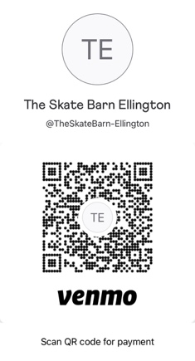
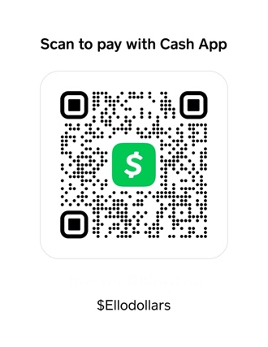
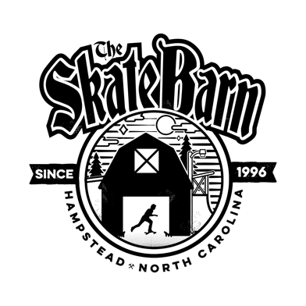

THE SKATE BARN

THE EGG BOWL JAM - SIGN UP

$20 Entry Fee (includes one event)

$5 EXTRA FOR BEST TRICK

We take advanced sign up! Email Theskatebarn@gmail.com / Call the shop @ (910)270-3497. We do Venmo & Cash App

Name: ______________ Rider Stance: Goofy / Regular

Age: ____ DOB______ City/State__________________ Contact#_________________

Sponsors________________________________________

INSTAGRAM @_______________________ SEND US A HEAD SHOT FOR your profile!

EVENTS (circle/highlight your entries): * DIVISIONS SUBJECT TO CHANGE*

THE EGG BOWL DIVISIONS

17 AND UNDER
18 - 34
35 - 49
50+
BEST TRICK

SKATE BARN EMPLOYEE USE

CHECKED IN BY (SB Employee Initials) _____

# Of events _____ TOTAL PAID ______

