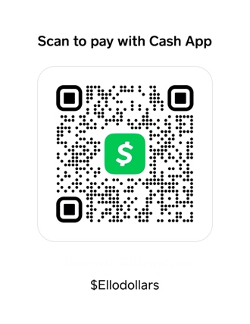
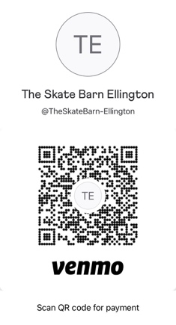
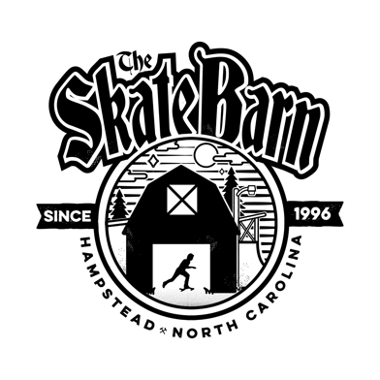

THE SKATE BARN

BANDS SIGN UP

We take advanced sign up! Email Theskatebarn@gmail.com /
Call the shop @ (910)270-3497. We do Venmo & Cash App

EVENT NAME: __________________

Band Contact Name: _________________________________

NAME OF BAND: ______________ Contact # ____________

EMAIL_____________________ SOCIAL MEDIA___________

COMPENSATION FOR EVENT $_____

We will discuss compensation with you prior to confirming the band to play. We will have a signed agreement to ensure there are no surprises for any involved. (Please remember we don’t have a bar to make money to pay expenses, The Skate Barn still must ensure a higher-than-normal income to pay the extra staff and cover our expenses.)

THIS SIGN-UP SHEET IS TO HELP THE PARK KEEP RECORD OF WHO IS LINED UP TO BE AT THE SKATE BARN EVENT. PLEASE COORDINATE WITH US TO ENSURE WE ALL KNOW WHAT TIME SET UP/ BREAKDOWN TIMES ARE. PLEASE BE RESPECTFUL OF THE PROPERTY / EMPLOYEES AND GUESTS OF THE SKATE BARN AT ALL TIMES.

SKATE BARN MANAGER USE

CHECKED BY (SB Manager Signature) _______________________

TOTAL PAID_______

Band member Signature: _________________

